**NERC Map-en.svg**

From Wikimedia Commons, the free media repository

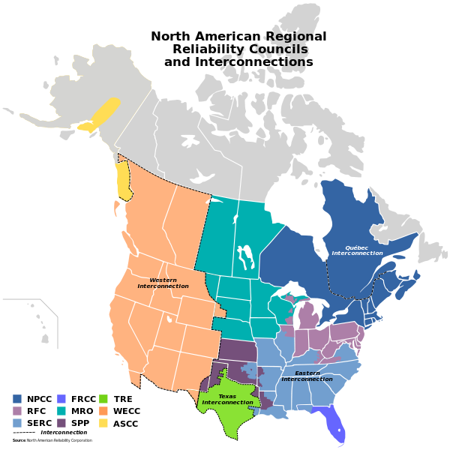

Size of this PNG preview of this SVG file: [600 × 600 pixels](https://upload.wikimedia.org/wikipedia/commons/thumb/f/f4/NERC-map-en.svg/600px-NERC-map-en.svg.png). Other resolutions: [240 × 240 pixels](https://upload.wikimedia.org/wikipedia/commons/thumb/f/f4/NERC-map-en.svg/240px-NERC-map-en.svg.png) | [480 × 480 pixels](https://upload.wikimedia.org/wikipedia/commons/thumb/f/f4/NERC-map-en.svg/480px-NERC-map-en.svg.png) | [768 × 768 pixels](https://upload.wikimedia.org/wikipedia/commons/thumb/f/f4/NERC-map-en.svg/768px-NERC-map-en.svg.png) | [1,024 × 1,024 pixels](https://upload.wikimedia.org/wikipedia/commons/thumb/f/f4/NERC-map-en.svg/1024px-NERC-map-en.svg.png) | [1,730 × 1,730 pixels](https://upload.wikimedia.org/wikipedia/commons/thumb/f/f4/NERC-map-en.svg/1730px-NERC-map-en.svg.png).

[Original file](https://upload.wikimedia.org/wikipedia/commons/f/f4/NERC-map-en.svg) ‎(SVG file, nominally 1,730 × 1,730 pixels, file size: 272 KB)

This image rendered as PNG in other widths: [200px](https://upload.wikimedia.org/wikipedia/commons/thumb/f/f4/NERC-map-en.svg/200px-NERC-map-en.svg.png), [500px](https://upload.wikimedia.org/wikipedia/commons/thumb/f/f4/NERC-map-en.svg/500px-NERC-map-en.svg.png), [1000px](https://upload.wikimedia.org/wikipedia/commons/thumb/f/f4/NERC-map-en.svg/1000px-NERC-map-en.svg.png), [2000px](https://upload.wikimedia.org/wikipedia/commons/thumb/f/f4/NERC-map-en.svg/2000px-NERC-map-en.svg.png).

Viewer Configuration

**Summary**

|  |  |  |  |  |
| --- | --- | --- | --- | --- |
| **DescriptionNERC-map-en.svg** | | | **English:** English version of a map showing the Regional Reliability Councils and Interconnections in North America.  Based on [File:BlankMap-USA-states-Canada-provinces,_HI_closer.svg](https://commons.wikimedia.org/wiki/File:BlankMap-USA-states-Canada-provinces,_HI_closer.svg) by [Lokal Profil](https://commons.wikimedia.org/wiki/User:Lokal_Profil), CC-BY-SA 2.5, [File:Nercmap.JPG](https://commons.wikimedia.org/wiki/File:Nercmap.JPG) by [J JMesserly](https://commons.wikimedia.org/wiki/User:J_JMesserly) PD-Self  Data Source: [North American Reliability Corporation](http://www.nerc.com/fileUploads/File/AboutNERC/maps/NERC_Regions_color.jpg)  **Français :** Version anglaise d'une carte montrant les Conseils régionaux de fiabilité et les interconnexions de l'Amérique du Nord.  Basé sur [File:BlankMap-USA-states-Canada-provinces,_HI_closer.svg](https://commons.wikimedia.org/wiki/File:BlankMap-USA-states-Canada-provinces,_HI_closer.svg) par [Lokal Profil](https://commons.wikimedia.org/wiki/User:Lokal_Profil), CC-BY-SA 2.5, [File:Nercmap.JPG](https://commons.wikimedia.org/wiki/File:Nercmap.JPG) par [J JMesserly](https://commons.wikimedia.org/wiki/User:J_JMesserly) PD-lui-même  Source des données : [North American Reliability Corporation](http://www.nerc.com/fileUploads/File/AboutNERC/maps/NERC_Regions_color.jpg) | |
| **Date** | | | 10 May 2009 | |
| **Source** | | | Own work | |
| **Author** | | | [Bouchecl](https://commons.wikimedia.org/wiki/User:Bouchecl) | |
| **Other versions** | | | [Version française](https://commons.wikimedia.org/wiki/File:NERC-map-fr.svg) | |
|  | This [vector image](https://en.wikipedia.org/wiki/Vector_images) was created with [Inkscape](https://commons.wikimedia.org/wiki/Help:Inkscape). | |

**Licensing**

|  |  |  |  |  |  |
| --- | --- | --- | --- | --- | --- |
| **I, the copyright holder of this work, hereby publish it under the following license:**   |  |  |  | | --- | --- | --- | |  | This file is licensed under the [Creative Commons](https://en.wikipedia.org/wiki/en:Creative_Commons) [Attribution-Share Alike 3.0 Unported](https://creativecommons.org/licenses/by-sa/3.0/deed.en) license. |  | |  | | You are free:   * **to share** – to copy, distribute and transmit the work * **to remix** – to adapt the work   Under the following conditions:   * **attribution** – You must attribute the work in the manner specified by the author or licensor (but not in any way that suggests that they endorse you or your use of the work). * **share alike** – If you alter, transform, or build upon this work, you may distribute the resulting work only under the same or similar license to this one.   http://creativecommons.org/licenses/by-sa/3.0 CC BY-SA 3.0 Creative Commons Attribution-Share Alike 3.0 truetrue | |

**File History**

Click on a date/time to view the file as it appeared at that time.

|  |  |  |  |  |  |
| --- | --- | --- | --- | --- | --- |
|  | **Date/Time** | **Thumbnail** | **Dimensions** | **User** | **Comment** |
| current | [03:58, 11 May 2009](https://upload.wikimedia.org/wikipedia/commons/f/f4/NERC-map-en.svg) |  | 1,730 × 1,730 (272 KB) | [Bouchecl](https://commons.wikimedia.org/wiki/User:Bouchecl) ([talk](https://commons.wikimedia.org/wiki/User_talk:Bouchecl) | [contribs](https://commons.wikimedia.org/wiki/Special:Contributions/Bouchecl)) | {{Information |Description={{en|1=English version of a map showing the Regional Reliability Councils and Interconnections in North America. Based on [File:BlankMap-USA-states-Canada-provinces,_HI_closer.svg](https://commons.wikimedia.org/wiki/File:BlankMap-USA-states-Canada-provinces,_HI_closer.svg) by [Lokal Profil](https://commons.wikimedia.org/wiki/User:Lokal_Profil), CC-BY |

* You cannot overwrite this file.

**File usage on Commons**

The following page links to this file:

* [File:Nercmap.JPG](https://commons.wikimedia.org/wiki/File:Nercmap.JPG)

**File usage on other wikis**

The following other wikis use this file:

* Usage on de.wikipedia.org
  + [Kanada](https://de.wikipedia.org/wiki/Kanada)
  + [North American Electric Reliability Corporation](https://de.wikipedia.org/wiki/North_American_Electric_Reliability_Corporation)
  + [Western Interconnection](https://de.wikipedia.org/wiki/Western_Interconnection)
  + [Verbundnetz](https://de.wikipedia.org/wiki/Verbundnetz)
  + [Texas Interconnection](https://de.wikipedia.org/wiki/Texas_Interconnection)
* Usage on en.wikipedia.org
  + [North American Electric Reliability Corporation](https://en.wikipedia.org/wiki/North_American_Electric_Reliability_Corporation)
  + [Texas Interconnection](https://en.wikipedia.org/wiki/Texas_Interconnection)
  + [Eastern Interconnection](https://en.wikipedia.org/wiki/Eastern_Interconnection)
  + [Western Interconnection](https://en.wikipedia.org/wiki/Western_Interconnection)
  + [Reliability First](https://en.wikipedia.org/wiki/ReliabilityFirst)
  + [Florida Reliability Coordinating Council](https://en.wikipedia.org/wiki/Florida_Reliability_Coordinating_Council)
  + [Northeast Power Coordinating Council](https://en.wikipedia.org/wiki/Northeast_Power_Coordinating_Council)
  + [SERC Reliability Corporation](https://en.wikipedia.org/wiki/SERC_Reliability_Corporation)
  + [Quebec Interconnection](https://en.wikipedia.org/wiki/Quebec_Interconnection)
  + [Alaska Systems Coordinating Council](https://en.wikipedia.org/wiki/Alaska_Systems_Coordinating_Council)
  + [Wide area synchronous grid](https://en.wikipedia.org/wiki/Wide_area_synchronous_grid)
  + [Electricity sector of the United States](https://en.wikipedia.org/wiki/Electricity_sector_of_the_United_States)
  + [Tres Amigas SuperStation](https://en.wikipedia.org/wiki/Tres_Amigas_SuperStation)
* Usage on fr.wikipedia.org
  + [Interconnexion du Québec](https://fr.wikipedia.org/wiki/Interconnexion_du_Qu%C3%A9bec)
  + [Utilisateur:Bouchecl/Contributions](https://fr.wikipedia.org/wiki/Utilisateur:Bouchecl/Contributions)
  + [Tres Amigas SuperStation](https://fr.wikipedia.org/wiki/Tres_Amigas_SuperStation)
* Usage on ru.wikipedia.org
  + [Электроэнергетика США](https://ru.wikipedia.org/wiki/%D0%AD%D0%BB%D0%B5%D0%BA%D1%82%D1%80%D0%BE%D1%8D%D0%BD%D0%B5%D1%80%D0%B3%D0%B5%D1%82%D0%B8%D0%BA%D0%B0_%D0%A1%D0%A8%D0%90)

**Metadata**

This file contains additional information, such as [Exif](https://commons.wikimedia.org/wiki/Commons:Exif) metadata, probably added from the digital camera or scanner used to create or digitize it. If the file has been modified from its original state, some details may not fully reflect the modified file. The timestamp is only as accurate as the clock in the camera, and it may be completely wrong.

|  |  |
| --- | --- |
| **Width** | 1730 |
| **Height** | 1730 |

Retrieved from "<https://commons.wikimedia.org/w/index.php?title=File:NERC-map-en.svg&oldid=167147009>"

[Categories](https://commons.wikimedia.org/wiki/Special:Categories):

* [Electric power grid maps of the United States](https://commons.wikimedia.org/wiki/Category:Electric_power_grid_maps_of_the_United_States)
* [Energy maps](https://commons.wikimedia.org/wiki/Category:Energy_maps)
* [Energy in Canada](https://commons.wikimedia.org/wiki/Category:Energy_in_Canada)
* This page was last modified on 30 July 2015, at 05:39.